**The Influence of Academic Anxiety on High School Students Self-Esteem**

Antonia DeMaria

**Abstract**

Academic anxiety is the feeling of uneasiness over academic tasks. As testing requirements have increased, more pressure has been put on students across the globe. The increase in pressure has taken a toll on high school students' mental health. Past studies have found that male students tend to have a higher self-esteem level than female students. My prediction is that female students will report higher levels of academic anxiety with lower levels of self-esteem. Skepticism is the doubt about something. Some students believe that school will not help them in the future, this may impact the way students view school and their academic performance. Additionally, I predicted that students who are skeptical about schools' relevance for future success will report lower levels of academic anxiety with higher levels of self-esteem. High school students completed various scales in an online environment evaluating demographics, academic anxiety, self-esteem, and skepticism about the relevance of school for future success. The scale was left open for 4 weeks in which participants were able to complete the questionnaire on their leisure time. Results were analyzed in Microsoft Excel to find a correlation between academic anxiety to self-esteem, and a correlation between the skepticism scale to the academic anxiety and self-esteem scales. Results found may be used to help high schools develop programs aimed to help students cope with their academic anxiety and maintain a healthy self-esteem level. Researchers suggest future studies should include more variables such as social and academic background.

**Introduction**

Test anxiety has detrimental effects on the academic performance of many university students ( Nunez-Pena, Saurez-Pellicioni, Bono, 2016). As there is an increase in testing requirements for students there is also an increase in the amount of pressure students are feeling. According to the American College Health Association, in the spring of 2019 50.7% of male students and 71.8% of female students have felt an overwhelming amount of anxiety within the last 12 months. It is concerning to realize how much students are affected by anxiety. It is important to study this topic because prolonged anxiety can interfere with social obligations, family and work settings. Additionally, prolonged anxiety can contribute to chemical imbalances which can put individuals at risk for emotional disorders or diseases.

A study conducted in 2011 (Bagana, Raciu & Lupu) showed that there is a negative relationship between test anxiety and self-esteem. Researchers collected data through various self-reported scales such as the Rosenberg Self-Esteem Scale (Rosenberg, 1965, 1989, Blascovich & Tomaka, 1991) and the Test Anxiety Scale (Spielberger 1979, 1980). The results of this study were correlated to past studies finding that self-esteem and test anxiety have a negative relationship (Spielberger, 1966; Rosenberg et al., 1989; Ringeisen and Buchwald, 2010). However, this 2011 study reported a larger sample size in future studies would be beneficial. Results from this study may be used by school counselors to develop programs to help with student anxiety.

Test anxiety is defined as the feeling of nervousness before taking an exam. These feelings may stem from lack of preparation or the fear of failure (<https://adaa.org/living-with-anxiety/children/test-anxiety>). Studies have illustrated that test anxiety is more common in women than men. Additionally, ten million elementary students are not performing at their highest potential due to test anxiety (Ergene, 2003, p. 314).

Researchers have made the observation that an increase in student anxiety may be caused by the increase in testing requirements (Whitaker et al., 2007). Techniques such as deep breathing and muscle relaxation have been shown to decrease anxiety in individuals who have a hard time relaxing during stressful situations (Zuercher-White, 1998).

As we are growing up, our successes and failures through life and how we are treated by co-workers, teachers, parents and peers all have an impact on our basic self-esteem ( Yaratan and Yucesoylu, 2010). Studies have shown that self-esteem and academic achievement have a direct relationship. Therefore, as academic achievement increases, self-esteem will increase. However, when academic achievement is lacking, self-esteem tends to decrease (Bankston & Zhou, 2002; Lockett & Harrell, 2003; Schmidt & Padilla, 2003). Previous students have indicated that self-esteem may be related to components of success, either academically or verbally (Purky, 1970). Thus, students associate their self-worth with school achievements.

Skepticism is the doubt about something. In this study, I am examining how the doubt about schools' relevance for future success impacts students' academic anxiety and self-esteem. However, there is a lack of studies researching skepticism about schools' relevance for future success and its relationship towards beliefs of students. Due to the lack of research regarding academic skepticism, there is a gap in my research.

I hypothesized that female students who experience higher levels of test anxiety will report a lower level of self-esteem and students who are skeptical about schools' relevance for future success will report a lower level of test anxiety and a higher level of self-esteem.

**Methodology:**

Due to COVID-19 some of my method designs needed to be changed. Originally, I was planning students to complete various scales on paper in a classroom setting to mock an academic test. However, due to the unforeseen events, the scales were transferred to a Microsoft Form where participants could engage virtually.

Digital flyers were posted on teachers homepages to encourage participation. Those interested would email the research supervisor and then the link to the online questionnaire would be shared with participants. All participants are high school students whose age ranges from fourteen to eighteen years of age, participants range in ethnicity and grade, there were a total of 10 participants, 9 females and 1 who chose not to disclose their gender.

A Microsoft Form questionnaire was created which consisted of consenting the use of responses in analysis, demographics (age, gender, grade, ethnicity), eleven items from the Academic Anxiety Scale, ten items from the Rosenberg Self-Esteem Scale and six items from the Skepticism about Schools Relevance for Future Success Scale. Additionally, there was a disclaimer stating participants who have been medically diagnosed with anxiety and/or taking anxiety medication should not participate as it may skew results. The questionnaire was left open for 4 weeks which allowed participants to complete the questionnaire in their leisure time. The average completion time of the questionnaire was five minutes and forty seconds.

Due to the low participation, I decided to re-open the questionnaire for an additional 4 weeks to gain increased participation. Interested participants had to complete a parental consent form, give the form to my research supervisor, then the questionnaire was provided.

**Results:**

Raw data was transferred from the questionnaire into a Microsoft Excel spreadsheet. For each question, descriptive statistics (mean, mode, range etc) was calculated. Then the Academic Anxiety Scale, Rosenberg Self-Esteem Scale and the Skepticism about Schools’ Relevance for Future Success Scale was scored.

The Academic Anxiety Scale consists of 11 items that range from 1 (not typical of me) to 4 (very typical of me.) I added up the total score for each participant, the total score ranged from 13-37. The mean academic anxiety score across the ten participants was 27.3.

The Rosenberg Self-Esteem Scale consists of 10 items, where questions 2,5,6,8 and 9 are reversed scored. The items range from 1 (strongly disagree) to 4 (strongly agree.) The reverse scored items range from 1 (strongly agree) to 4 (strongly disagree.) I added up the total score for each participant, the total score ranged from 14-34 with a mean self-esteem score of 23.8.

The Skepticism about Schools’ Relevance for Future Success consists of 6 items that range from 1 (not true at all) to 5 (very true.) I added up the responses from each participant and the total score of skepticism about schools' relevance for future success ranged from 6-22. The mean score of skepticism across the participants is 10.

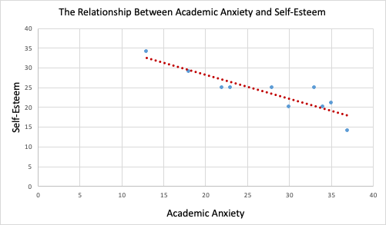 Following, I created correlation and regression between the Academic Anxiety Scale and the Rosenberg Self-Esteem Scale. I found there is a negative relationship between academic anxiety and self-esteem with a numerical value of -0.889. Next, a regression analysis was performed. A p-value of .0005 was found which is less than .05 so the relationship between academic anxiety and self-esteem is significant.

Figure 1 shows that there is a negative relationship between Academic Anxiety and Self-Esteem.

Then a correlation between the Academic Anxiety Scale and the Skepticism About Schools’ Relevance for Future Success was found. There is a positive relationship between skepticism and academic anxiety with a numerical value of 0.096. A p-value of .08 was found which is greater than .05, therefore the relationship between skepticism about schools’ relevance for future success and academic anxiety is not statistically significant.

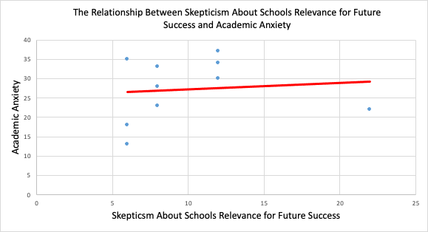

Figure 2 shows that there is a positive relationship between Skepticism About Schools’ Relevance for Future Success and Academic Anxiety.

Lastly, a correlation was found between the Skepticism About Schools’ Relevance for Future Success Scale and the Rosenberg Self-Esteem Scale. A negative relationship between skepticism and self-esteem was found with a numerical value of -0.323. A p-value of .4 was calculated illustrating the relationship between skepticism and self-esteem is not statistically significant.

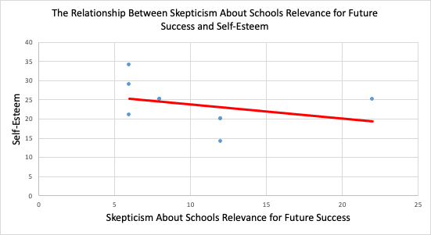

Figure 3 shows that there is a negative relationship between Skepticism About Schools’ Relevance for Future Success and Self-Esteem.

**Conclusions:**

With the results, my research questions can now be answered. One of my research questions was: Are there differences in high school students’ level of self-esteem and academic anxiety according to their gender? Since there were 9 female participants and 1 participant who chose not to disclose their gender, I cannot conclude based on my results if gender impacts one’s academic anxiety and self-esteem. However, it is important to note that as academic anxiety increased, self-esteem decreased. My second research question was: Are there differences in high school students’ level of academic anxiety and self-esteem based on skepticism of schools' relevance for future success? I found that as skepticism increased, academic anxiety increased while self-esteem decreased.

One of my hypotheses was: Female students who experience more academic anxiety than male students will have a lower self-esteem than male students. Due to the lack of male participants, I cannot support or reject the above hypothesis based on the data I collected. However, I did find that those who experienced higher academic anxiety had a lower self-esteem. This conclusion is in line with many previous studies. Additionally, I hypothesised that students who are skeptical about schools' relevance for future success will have a lower level of academic anxiety and a higher level of self-esteem. This hypothesis cannot be supported based on the data I collected as I found that students who are skeptical about schools’ relevance for future success reported a higher level of academic anxiety with a lower level of self-esteem.

**Discussion:**

A limitation to my study was the small sample size. As there were only 10 total participants, I can only make conclusions based on 10 people which does not represent the entire population of high school students. Additionally, since there were no male participants, I can only make conclusions based on the female participants and I cannot conclude if there are any differences in academic anxiety and self-esteem based on gender differences. Due to the limited sample size, I decided to reopen the questionnaire 9 months later to gain additional participation. For future studies, I would keep the questionnaire open for an additional 2 weeks, making the questionnaire open for a total of 6 weeks to gain participation. The addition of variables such as academic and social background would also strengthen my study. Lastly, results gathered in studies may be used by school counselors and medical professionals to develop programs aimed to reduce high school students' academic anxiety and increase students’ self-esteem.

**References:**

Bankston, C. L. & Zhou, M. (2002). Being well vs. doing well: Self-esteem and school performance among immigrant and non-immigrant racial and ethnic groups. *International Migration Review*, 36, 389-415.

Bagana, E., Raciu, A., & Lupu, L. (2011). Self esteem, optimism and exams’ anxiety among high school students. *Procedia - Social and Behavioral Sciences,* *30*, 1331-1338. doi:10.1016/j.sbspro.2011.10.258

Blascovich, J., & Tomaka, J. (1991). Measures of self-esteem. In J. P. Robinson, P. R. Shaver, & L. S. Wrightsman. (Eds), *Measures of personality and social psychological attitudes. Measures of social psychological attitudes:* Vol. 1 (pp. 115-160). San Diego: Academic Press.

Cassady, J.C., Pierson, E. E., & Starling, J. M. (2019). Predicting student depression with measures of general and academic anxieties. Frontiers in Education: Educational Psychology, 4(11). doi: 10.3389/feduc.2019.00011

Ergene, T. (2003). Effective interventions on test anxiety reduction: A meta-analysis. *School Psychology International, 24*(3), 313-328. doi: 10.1177/01430343030243004

Lockett, C. T. & Harrell, J. P. (2003). Racial Identity, self-esteem, and academic achievement: Too much interpretation, too little supporting data. *Journal of Black Psychology*, 29(3), 325-336.

Midgley, C., Maehr, M. L., Hruda, L. Z., Anderman, E., Anderman, L., Freeman, K. E., Gheen, M., Kaplan, A., Kumar, R., Middleton, M. J., Nelson, J., Roeser, R., & Urdan, T., *Manual for the Patterns of Adaptive Learning Scales (PALS)*, Ann Arbor, MI: University of Michigan, 2000.

Núñez-Peña, M. I., Suárez-Pellicioni, M., & Bono, R. (2016). Gender Differences in Test Anxiety and Their Impact on Higher Education Students’ Academic Achievement. *Procedia - Social and Behavioral Sciences,* *228*, 154-160. doi:10.1016/j.sbspro.2016.07.023

Purky, W. (1970). *Self concept and school achievement*. New Jersey: Prentice-Hall.

Ringeisen,T., Buchwald, P. (2010). Test anxiety and positive and negative emotional states during an examination. *Cognition, Brain, Behavior. An Interdisciplinary Journal*, Volume XIV, No. 4 (December), 431-447

Rosenberg, M. (1965). *Society and the adolescent self-image*. Princeton, N.J.: Princeton University Press.

Rosenberg, M. (1989). *Society and the adolescent self-image*. Middletown, CT: Wesleyan University Press.

Schmidt, J. A., & Padilla, B. (2003). Self-esteem and family challenge: An investigation of their effects on achievement. *Journal of Youth and Adolescence*, 32, 37-46.

Spielberger, C. D. (1979). *Understanding stress and anxiety*. New York: Harper.

Spielberger, C.D., (1980). *Test Anxiety Inventory*. Palo Alto, CA: Consulting Psychology Press.

Spielberger, C. D. (1966). The effect of anxiety on complex learning, and academic achievement. In C. D. Spielberger (Ed.), *Anxiety and behavior*, New York: Academic Press, pp. 361-398.

Whitaker Sena, J.D., Lowe, A.P., Lee, W.S. (2007). Significant Predictors of Test Anxiety among Students with and Without Learning Disabilities. *Journal of Learning Disabilities*; 40, 4.

Yaratan, H., Yucesoylu, R. (2010). Self-esteem, self-concept, self-talk and significant others’ statements in fifth grade students: Differences according to gender and school type. *Procedia Social and Behavioral Sciences, 2, 3506*–*3518.*

Zuercher-White, E. (1998). *An end to panic breakthrough techniques for overcoming panic disorder*. Oakland, CA: New Harbinger Publications.